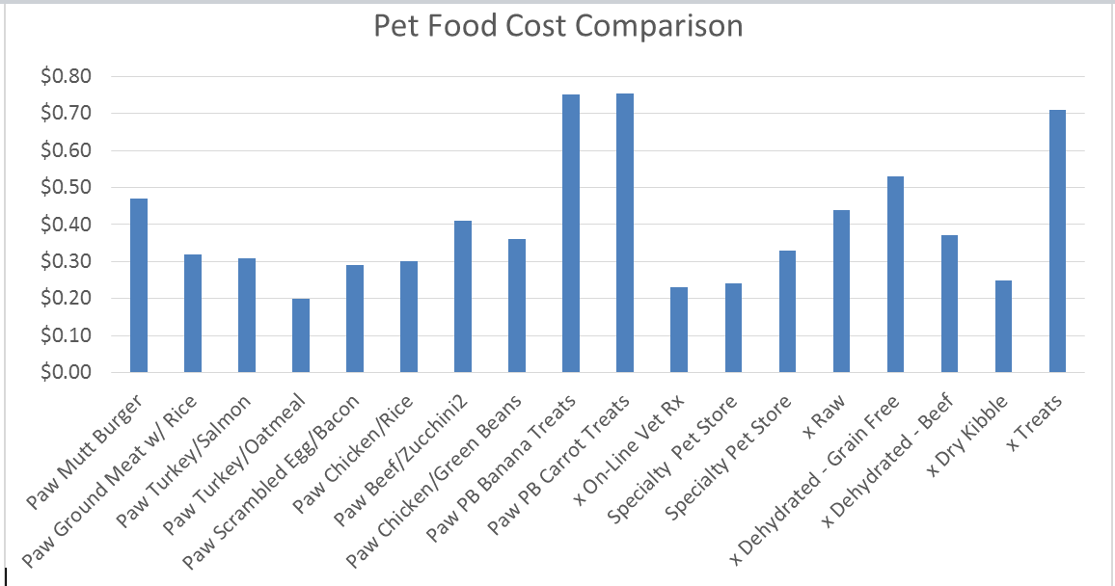
After pricing pet foods and pet treats on-line and at many local pet stores, my daughter created this chart for me to compare the costs of Pawlicious foods (on the left) to store-bought foods. As you can see by comparison there is not much difference in costs---BUT the benefits of Pawlicious are beyond comparison!
Pawlicious Pet meals do not add any by-products, additives, or preservatives. It’s simple and clean. Pawlicious uses the same ingredients you and I would purchase and prepare for ourselves to eat.
It is homemade in small batches so it hasn’t been stored in the freezer for long periods.
Pawlicious has a variety of foods to choose from so your pet is not eating the same food day in and day out.
We know as humans that eating lots of processed foods with carbs and sugar in our diet, can lead to problems with excessive weight, diabetes, and heart conditions. Our canine families also have these issues when eating dry kibble and canned dog foods. These processed foods have ingredients you and I don’t recognize and some may cause cancer.
Your canine family can benefit from Pawlicious with a good body weight, longer longevity, less ear or eye infections, less gas, and a healthy gut.
Get your canine family eating good, simple, clean and healthy foods with Pawlicious Pet products.

